Next Era Ed – Working through your Solutions

What is your school’s vision of student success?
Criteria / Heading | Description
Lifelong Learners | Students have a drive to continue exploring and develop their interests
etc. | …

What criteria do you collect data on to measure achievement of the vision?
lifelong learning | critical thinking | resilient | outward-looking
 |  |  | etc.

What learning theories provide “if-then” guidance on achieving the vision or generating needed evidence?
Theory & Target | If (with vision or evidence criteria) | Then (anticipated result)
Lifelong Learners / SOLE (Self Organised Learning Environments) | IF SOLE promotes students’ ability to problem-solve “how to learn” … | THEN, regular use of SOLE approach should promote student interest and ability at tackling new challenges.
etc. | …

How could the Curriculum be updated to increase achievement of the Vision, generation of Evidence or use of chosen Learning Theories and your hypotheses?
(besides targeting your chosen aspects, also consider “13 Reasons Why Digital Learning is Better”)
Approach | Description | Vision | Evidence | Learning  Theories | ICT Advantage
Thinking Routines (from Project Zero – Harvard) | Use Look to Learn Tumblr and others as daily warm-up and discussion topics in tutor groups | √ | √ | √ | Rich Media, personalisation, engagement
etc.

How is achievement regularly reviewed by staff?
When? | Format / time? | Who? | Aspect Reviewed | Action
End Term 1 | ½ day Dept group meetings | All staff by faculties | Alignment of Evidence criteria with Common tasks | Revise Common tasks for next term if they do not align with criteria
etc.

Next Era Education:
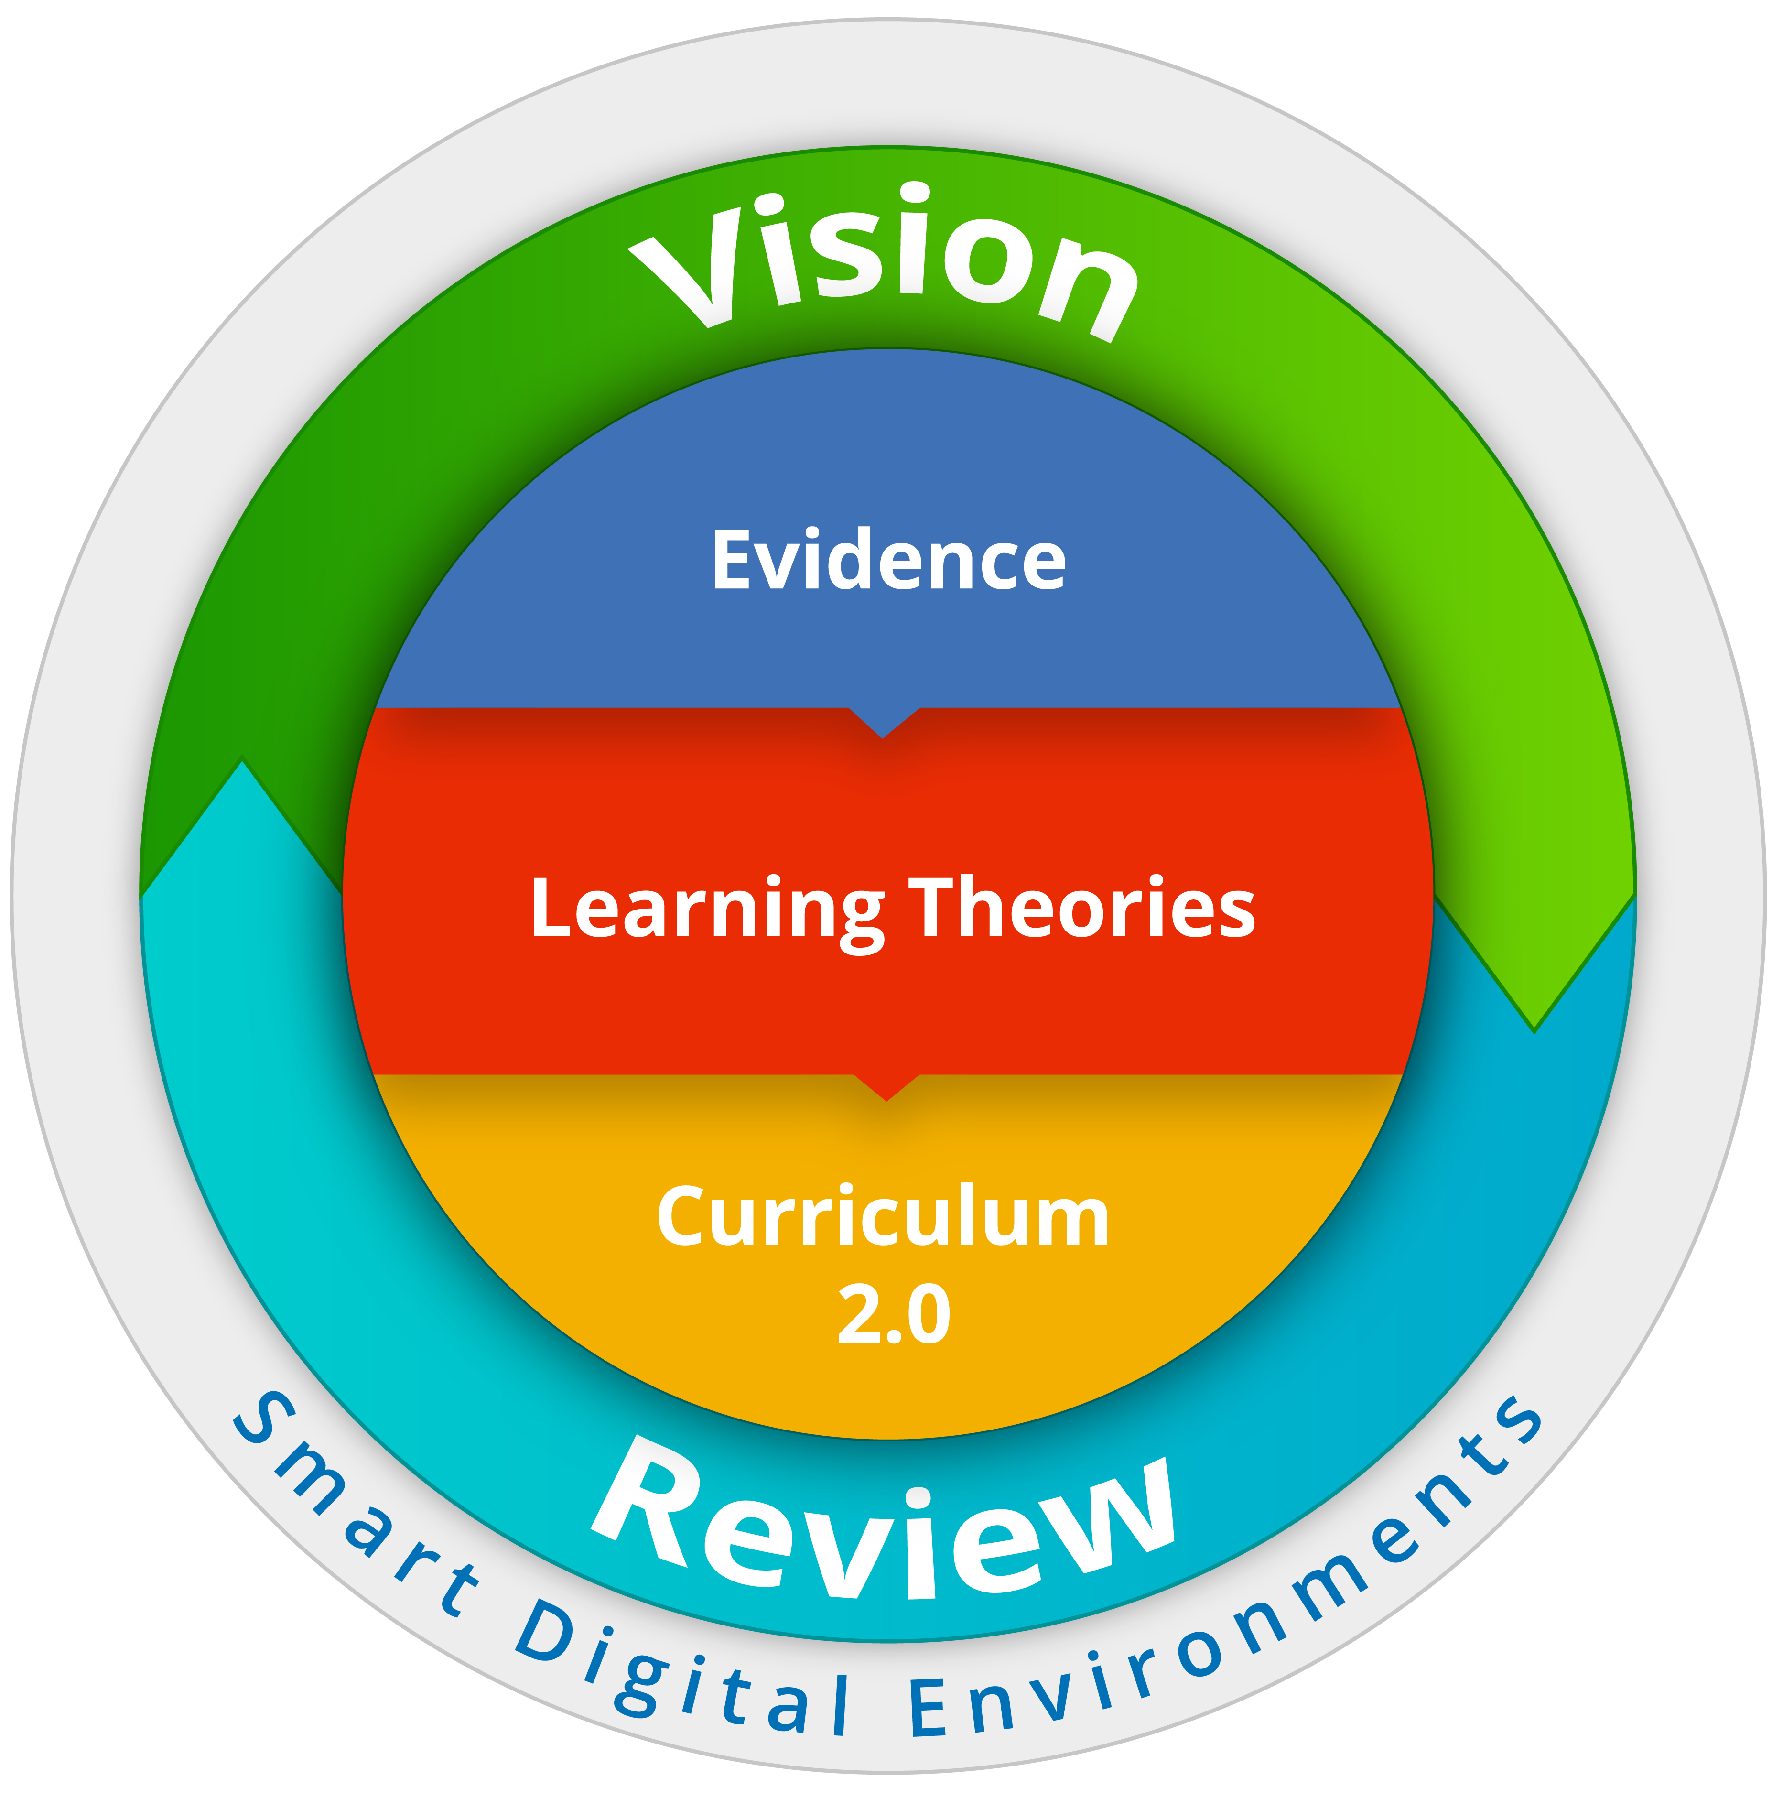
Shift from massed produced schooling to personally meaningful learning.

What Software does your school use to achieve student success?
Platform / purpose? | Used? | Part of one database?
Curriculum Design
Resource management
Online Learning
ePortfolio / Publish sites
Assessment Builders
Learning Data (Markbook Analytics)
Welfare and personal learning goals

Readings and Resources
- Schools: Invent The Next Era Of Education - Tom March, published in Education Technology Solutions, September 23, 2015

