The Four Requirements for
Successful School-based 1:1 Learning
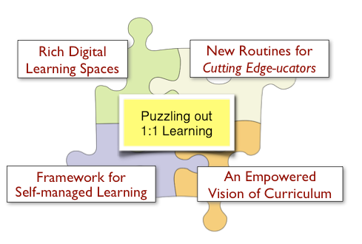
Premise: When students have 1:1 access to rich digital resources, the technology can disrupts the traditional one-to-many teaching or render it less effective.
For a 1:1 approach to be successful, four critical aspects must be addressed. Leaving any one of them out undermines the entire effort.

Rich Digital Learning Spaces
The classroom is the traditional location for learning in a school. When students have personal digital devices, they similarly need a place to meet to engage in meaningful learning experiences. A school must provide a secure online space that supports rich media and intuitive publishing and collaboration.
Without Rich Digital Learning Spaces students cannot meet and work as a class.

New Routines for Cutting Edge-ucators
The common routines of “chalk and talk”, group projects, research and discussions are all either undermined or under-utilise technology. Teachers and students need new routines that support advanced learning and take advantage of both the 1:1 and collaborative nature of digital learning.
Without New Routines teachers will under utilise technology’s potential for powerful learning.

An Empowered Vision of Curriculum
A Board of Studies Syllabus or an Australian Curriculum provides the framework for teaching practice and learning outcomes. When teachers are the source of the information, they do their best to anticipate and modify their instruction to suit their students. When students have 1:1 access to learning, how do we know what they have learned? How do we help them progress? An empowered vision of curriculum provides multiple pathways through content, skills and understandings and presents learning in the disciplines as a continuum where students can achieve at their own pace and fulfil their potential across a matrix of competencies.
Without an empowered Vision, students will be left with a one-size-fits-all Curriculum

A Framework for Self-managed Learning
Much of traditional teaching focuses on classroom management. Orchestrating more than 20 students to move in the same direction requires considerable skill. When students work independently via 1:1 devices, they must take control of their own learning or fall victim to distractions and amusements. The fact that students’ learning scenario is already 1:1 outside of school should motivate schools to provide a framework to support and scaffold student autonomy and self-directed learning.
Without a framework for Self-managed learning students are “left to their own devices.”

