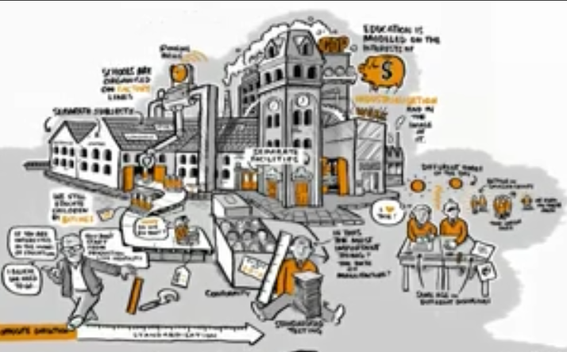

Designing School 3.0 WebQuest

Group Transformation Task

Instructions:
 | 20th Century Schools | 21st Century Schools
Technology | Textbooks, chalkboards, ?
School’s Purpose | Scale & Achieve Uniform Standards
Best Pedagogies | Curriculum, Year Levels & Instruction
Creative solution | School 2.0: Assembly Line Schools
This sheet is to guide your through creatively problem-solving a new design for large-scale education. Your task is to think beyond the current model because it is based on assumptions that are no longer valid.

- Use the table below to detail what you have have learned from your roles in the WebQuest (http://ozline.com/workshops/2011/08/18/webquests-day-1/)
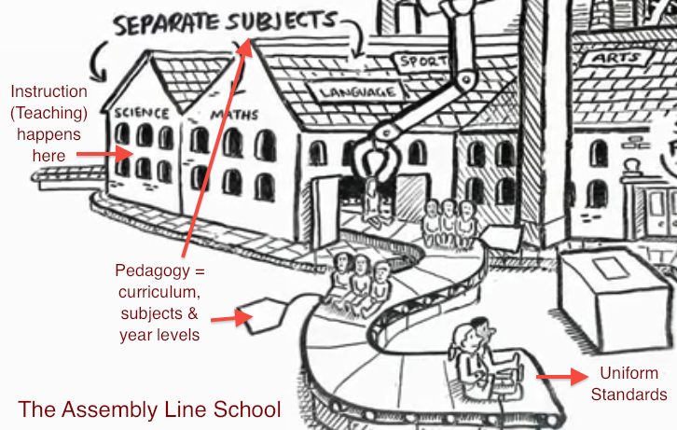
- Deconstruct the Logistics from the learning. What aspects in The Assembly Line School (below) are there simply to address the need to scale? What other elements are part of the “picture” but not show here? (e.g., “Assessments,” “Behavioural Rules,” etc.). Add them in.
- Make Your Own version of School 3.0. Using items from your table above, draw something that depicts a model for 21st Century Schools that take into account current and emerging digital possibilities. Have fun with the walls, online resources, anything you like to create your new model!

