Introduction to UbD & Understanding

The Melbourne Declaration
Successful Learners…
- develop their capacity to learn and play an active role in their own learning
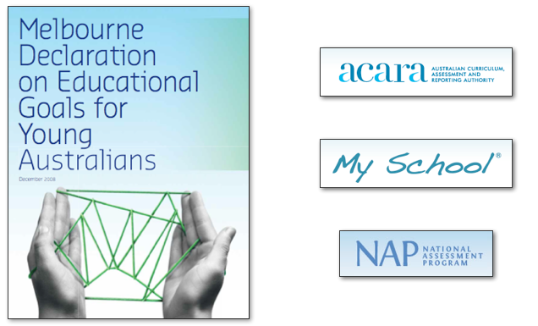
- have the essential skills in literacy and numeracy and are creative and productive users of technology, especially ICT, as a foundation for success in all learning areas
- are able to think deeply and logically, and obtain and evaluate evidence in a disciplined way as the result of studying fundamental disciplines
- are creative, innovative and resourceful, and are able to solve problems in ways that draw upon a range of learning areas and disciplines
- are able to plan activities independently, collaborate, work in teams and communicate ideas
- are able to make sense of their world and think about how things have become the way they are
- are on a pathway towards continued success in further education, training or employment, and acquire the skills to make informed learning and employment decisions throughout their lives
- are motivated to reach their full potential.

Knowing, Doing and Understanding

Things you “Know” | Skill you can “do” | Things you “Understand”

Imagine a main learning Goal in your Key Learning Area(s) & brainstorm below:
Goals worthy of Accomplishment | Evidence of Accomplishment | Learning Activities to produce evidence

