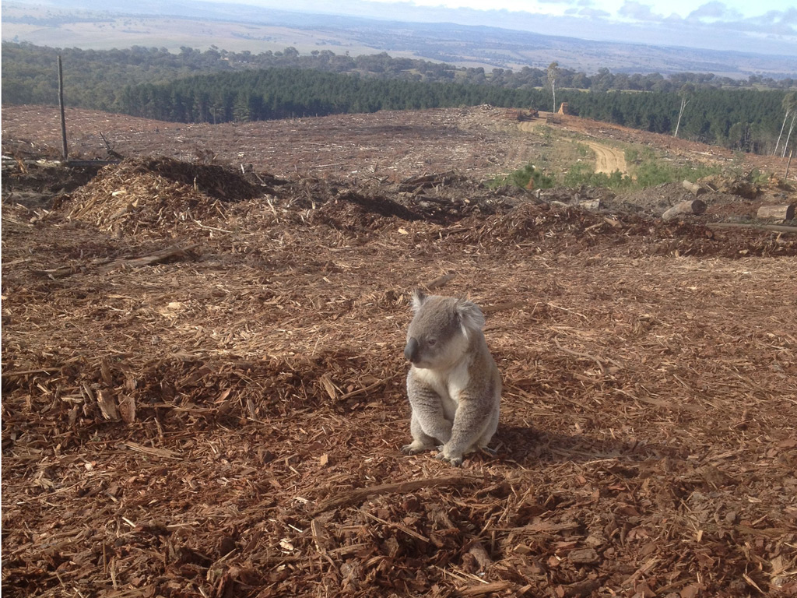

What makes you say that?

**Scan the QR Code to find out what 5/6a have to say!**

